**PROJECT REPORT**

**ON**

**“AN ED-TECH PLATFORM”**

**FOR**

**MES’S INSTITUTE OF MANAGEMENT AND CAREER COURSES**

**(IMCC)**

**BY**

**VISHAL DILIP GUNJAL**

**SAVITRIBAI PHULE PUNE UNIVERSITY**

**MASTER IN COMPUTER APPLICATION**

**MAHARASHTRA EDUCATION SOCIETY’S**

**INSTITUTE OF MANAGEMENT AND**

**CAREER COURSES (IMCC) PUNE - 411038**

**2023 - 2024**

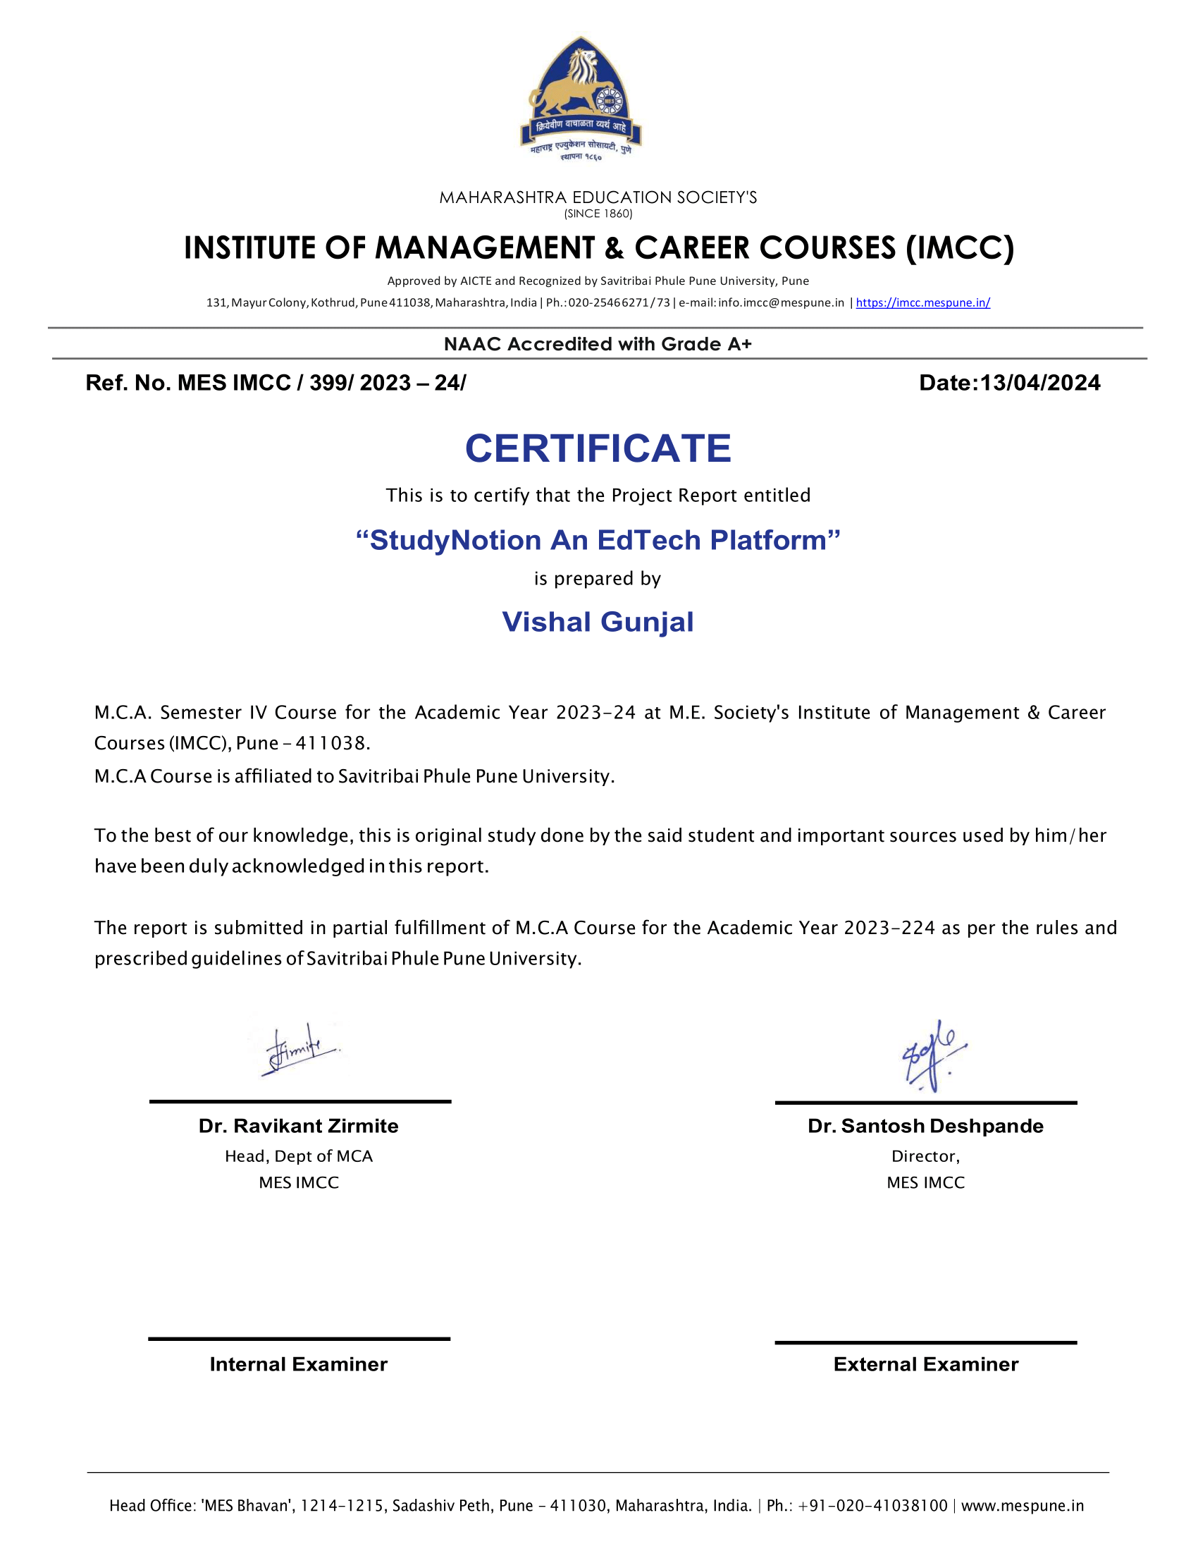

**CETIFICATE**

This is certified that the student **Vishal D. Gunjal** has completed the project work entitled “***StudyNotion An EdTech Platform***” under my guidance. The report is submitted in partial fulfilment of M.C.A Course for the Academic Year 2023 – 2024 as per the rules & prescribed guidelines of Savitribai Phule Pune University.

His/Her work is found to be satisfactory and complete in all reports.

**Dr. Shilpa Paralikar**

(Internal Project Guide)

**ACKNOWLEDGEMENT**

## I take great pride and pleasure in presenting the project report on “**StudyNation: An Ed-Tech Platform**” as required under the regulations of Savitribai Phule Pune University.

## I am deeply grateful to my project guide, **Dr. Shilpa Paralikar** for her invaluable guidance and constant supervision at every stage of the project. Without her support, the project would not have achieved its current shape and form. I extend my sincerest thanks to **Dr. Santosh Deshpande**, Director of MES’ IMCC, and **Dr. Ravikant Zirmite**, Head of the Department of MCA at MES’ IMCC, for their encouragement and for providing all the necessary facilities. I also express my gratitude to **Dr. Manasi Shirurkar**, Deputy Director of MES’ IMCC, for allocating adequate time for the project.

## Finally, I am extremely thankful to the teaching and non-teaching staff for their kind and wholehearted cooperation.

## **Vishal D. Gunjal.**

|  |  |  |  |
| --- | --- | --- | --- |
| **Chapter No.** **INDEX** | **Description** | | **Page No.** |
| **1.** | **Introduction** | | |
| 1.1 | Company Profile / Institute Profile / Client Profile | 1 |
| 1.2 | Abstract | 3 |
| 1.3 | Existing System and Need for System | 4 |
| 1.4 | Scope of System | 6 |
| 1.5 | Operating Environment – Hardware and Software | 9 |
| 1.6 | Brief Description of Technology Used1.6.1 Operating systems used (Windows or Unix)1.6.2 RDBMS/No SQL used to build (MySQL/ORACLE, Teradata, etc.) | 12 |
| **2.** | **Proposed System** | | |
| 2.1 | Study of Similar Systems | 13 |
| 2.2 | Feasibility Study | 15 |
| 2.3 | Objectives of Proposed System | 17 |
| 2.4 | Users of System | 20 |
| **3.** | **Analysis and Design** | | |
| 3.1 | System Requirements (Functional and Non-Functional Requirements) | 22 |
| 3.2 | Entity Relationship Diagram (ERD) | 26 |
| 3.3 | Table Structure | 27 |
| 3.4 | Use Case Diagram | 33 |
| 3.5 | Class Diagram | 37 |
| 3.6 | Activity Diagram | 38 |
| 3.7 | Deployment Diagram | 39 |
| 3.8 | Module Hierarchy Diagram | 40 |
| 3.9 | Sample Input and Output Screens (Screens must have valid data) | 41 |
| **4.** | **Coding** | | |
| 4.1 | Algorithms | 54 |
| 4.2 | Code snippets | 56 |
| **5.** | **Testing** | | |
| 5.1 | Test Strategy | 73 |
| 5.2 | Unit Test Plan | 76 |
| 5.3 | Acceptance Test Plan | 77 |
| 5.4 | Test Case / Test Script | 78 |
| 5.5 | Defect report / Test Log | 90 |
| **6** | **Limitations of Proposed System** | | 91 |
| **7** | **Proposed Enhancements** | | 94 |
| **8** | **Conclusion** | | 96 |
| **9** | **Bibliography** | | 97 |
| **10** | **Appendix** | | |
|  | Cost Sheet | 98 |
|  | Data Sheet | 99 |
| **11** | **User Manual (All screens with proper description / purpose details about validations related to data be entered.)** | | 100 |

**CHAPTER 1**

**INTRODUCTION**

**CHAPTER 2**

**PROPOSED SYSTEM**

**CHAPTER 3**

**ANALYSIS AND DESIGN**

**CHAPTER 4**

**CODING**

**CHAPTER 5**

**TESTING**

**CHAPTER 6**

**LIMITATION OF THE PROPOSED SYSTEM**

**CHAPTER 7**

**PROPOSED ENHANCEMENT**

**CHAPTER 8**

**CONCLUSION**

**CHAPTER 9**

**BIBLIOGRAPHY**

**CHAPTER 10**

**APPENDIX**

**CHAPTER 11**

**USER MANUAL**